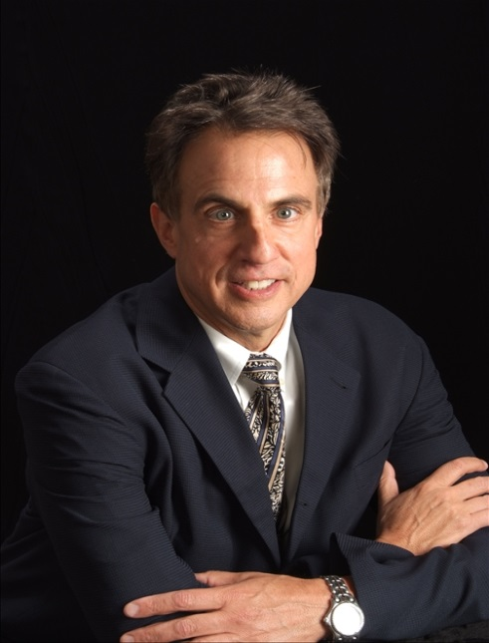
Russell Nassof, JD
Mr. Nassof is an attorney who has been involved in the fields of health risk consulting and clinician education for over 10 years concentrating his work in the areas of infection prevention, and risk/liability minimization for vascular access issues. . He has presented hundreds of seminars and webinars to legal, insurance, loss control, healthcare, and risk management groups throughout the United States, Canada, Europe, and Asia. While Mr. Nassof has been involved as a consulting/testifying expert on such diverse events as recent outbreaks of Legionnaires’ Disease, Middle East Respiratory Syndrome (MERS), and Ebola, his passion is focused on managing risk and liability for vascular catheter-associated risk and was recently the first non-clinician elected to the AVA Board of Directors and also served as a reviewer on the 2016 INS Standards. He has coauthored books on environmental/healthcare issues, holds a patent on a fungal sensing device and recently developed a peripheral catheter matrix addressing clinician best practice issues and liability minimization. Mr. Nassof received his Juris Doctorate and undergraduate degrees from Emory University in Atlanta.

