GREATER OHIO VASCULAR ACCESS NETWORK  P.O. Box 1036  Sunbury, OH 43074  Website:  govan8.wildapricot.org  E-mail:  govan.ava2012@gmail.com  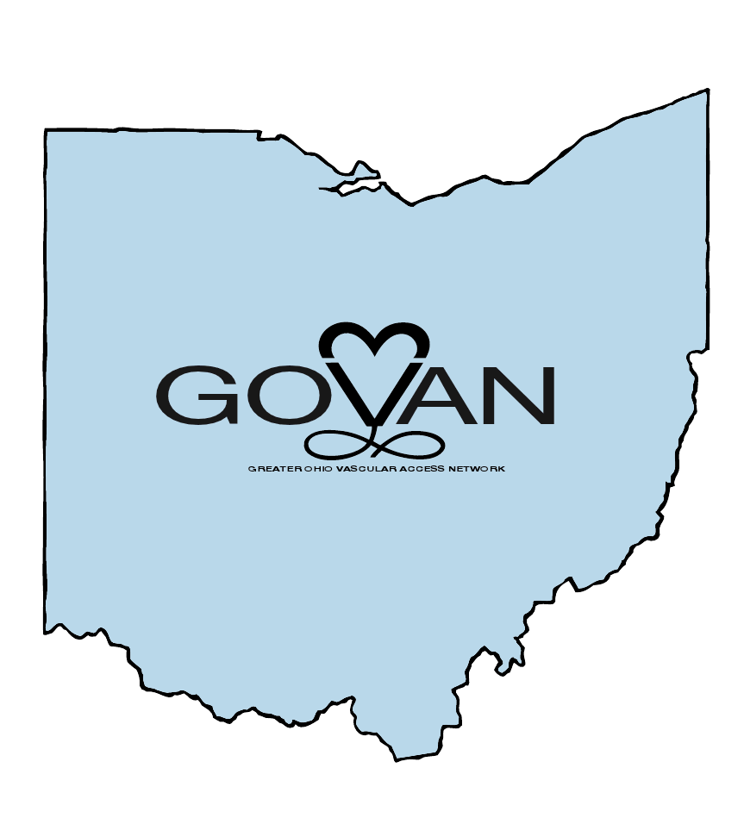 | Provider approved by the California Board of Registered Nursing, Provider Number CEP12371 for 6 Contact Hours  (Registration fee minus $10 processing fee will be returned if notified of non-attendance by April 12, 2017. No refund after April 12, 2017)  Overnight Accommodations:  For those arriving the evening prior (April 21st), Four Points by Sheraton is offering a discounted rate for Conference attendees. Your reservation will include lodging, free wireless internet, free parking, free Networking Reception (6p-9p). Please visit our exclusive GOVAN event link provided by Four Points by Sheraton:  https://www.starwoodmeeting.com/Book/GOVAN |  | Greater Ohio Vascular Access Network  Invites you to attend its 3rd Biennial Conference  “LET’S DO THIS…A Call to Action to Ensure Patient Safety While Protecting HealthCare Providers”  Saturday April 22, 2017  7:00am – 4:30pm  (Registration / Continental Breakfast / Vendor Exhibits begin at 7:00am; Program begins at 8:00am)  Quest Conference & Banquet Center  8405 Pulsar Pl  Columbus, OH 43240

Agenda:  7:00-8:00am – Registration / Manufacturer Exhibits / Breakfast  8:00-8:15am – Welcome / Announcements  8:15-9:15am – “PICCs for ID” – Mark Herbert, MD  - Discuss indications for PICC  - Review mgmt. of possible PICC complications  - Evaluate strategies for managing complicated pts  9:15-10:15am – “Placing PIV Catheters Under the Light Using NIR Technology” – Greg Schears, MD  - Describe use of NIR for screening & preassessment  - Identify valves, bifurcations & tortuosities using NIR  - Distinguish good vs. poor vascular access targets  10:15-10:45am – Break / Exhibits  10:45-11:45 – “Liability Under the ACA: What Clinicians Need To Know!” – Russ Nassof, JD  - Describe 5 pay for performance aspects of ACA  - List critical risk exposure points under the above  - Develop mitigation strategies  - Role and impact clinicians have w/ respect to their organization  - Understand potential opportunities for clinicians re: ACA | 11:45-12:45pm – “Preventing CLABSI – The Relationship Between Insertion and Care & Maintenance: Is the Dressing Important?” - Jack LeDonne, MD  - Explore EB CVC insertion & maintenance techniques  - Discuss how insertion impacts maintenance  - Describe practice changes impacting a pt’s risk factors for CLABSI  12:45-2:15pm – Lunch / Exhibits  2:15-3:15pm – “Don’t Be PICCY: Save the Veins!!” - Ravish Shah, MD  - Understand the “burden” of CKD  - Learn the “basics” of HD access  - Recognize “vein preservation” in CKD  - Understand EB guidelines re: PICC use in CKD  3:15-4:15pm – “Beyond the Status Quo: Silo-Free Vascular Access” – Judy Thompson RN, MSN Ed, VA-BC  - Describe current Vasc Access practice  - Describe ideal Vasc Access practice  - Describe obstacles to reaching “ideal”  - Describe tangible steps to reach “ideal”  - Describe motivation / need for advancing practice  - Describe benefits to advancing practice  4:15-4:30pm – Evaluations / Wrap-up | To Register:  - Visit our website at:  govan8.wildapricot.org  OR  - Complete the registration form below and mail with payment (check made payable to GOVAN) to address below.  Registration Types / Fees:  GOVAN / NEO-AVA / Buckeye INS Member: $60  Non-Member: $85  Name:______________________  Address:_____________________  City:________State:___Zip:_____  Email:_______________________  Employer:____________________  Title:________________________  Certification(s):________________  Affiliation(s):__________________  Professional License #:__________  Mail completed form w/payment to:  GOVAN  P.O. Box 1036  Sunbury, OH 43074

